# Assignment 3 Use Case

1. Note Application
   1. This app would take a note from a user and save it to its body of notes.
      1. 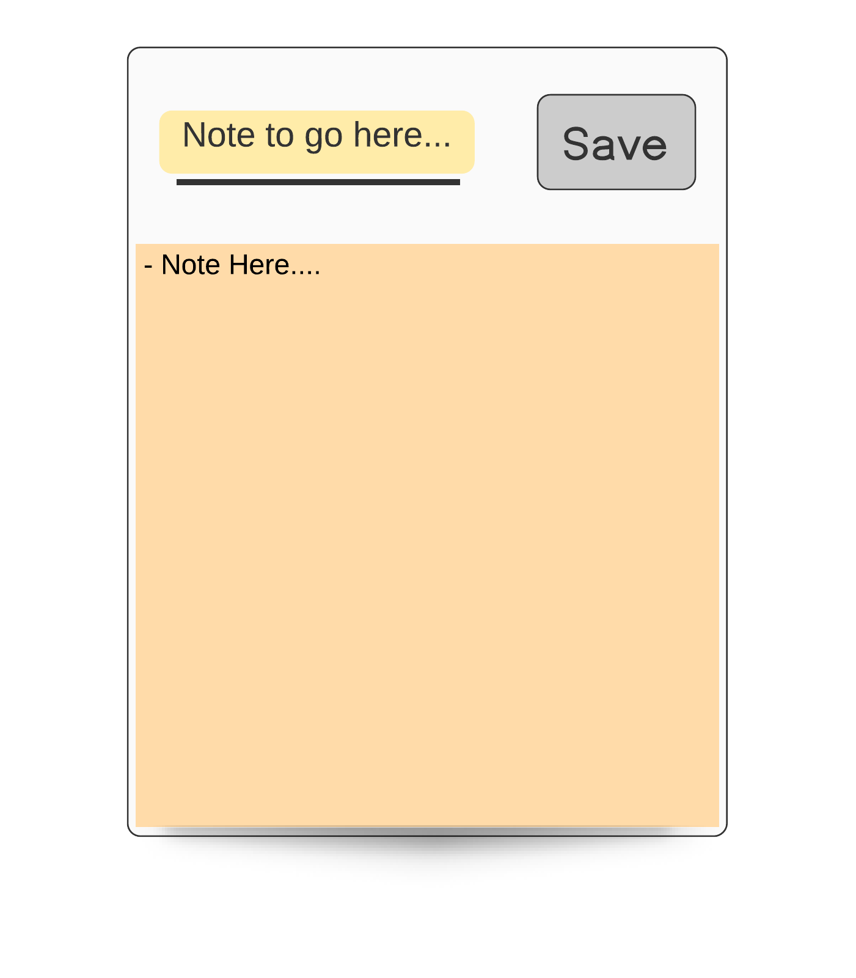As a I user I want to enter in the text box (1) my note

(1)

* + 1. Then I would click **Save** (2) and it would save to the body (3) …

(3)

(2)